Agile Sprint Planning & User Story Workshop Documentation

Intelligent AI-Based Smart Crop Disease Diagnosis and Yield Prediction System
CSA1017-SOFTWARE ENGINEERING

Name: - G. Ram Charan
Reg no: -192525043

1. Project Vision & Stakeholder Identification
Project Vision
The vision of this initiative is to empower modern agriculture by creating an intelligent, precision-farming ecosystem that integrates computer vision, IoT-based environmental tracking, and predictive weather analytics. The system transforms traditional reactive farming into proactive management, enabling farmers to anticipate challenges rather than merely respond to them. By automating rapid crop disease identification, delivering highly accurate yield forecasts, and recommending targeted treatment protocols, the platform maximizes farm profitability, reduces chemical runoff, and contributes to sustainable food production. Ultimately, this ecosystem bridges cutting-edge technology with agricultural practice, ensuring food security while promoting environmental stewardship.
Key Stakeholders and Their Roles
Primary Farmers / Smallholders Farmers are the direct end-users of the mobile application. They upload crop leaf images for disease detection, receive real-time IoT and weather alerts, and access personalized yield forecasts.
Agronomists & Plant Pathologists These domain experts validate the AI-driven disease detection models and ensure scientific accuracy. They review outlier cases, refine diagnostic algorithms, and curate the authoritative treatment recommendation database. Their expertise guarantees that the system’s outputs are reliable.
Farm Enterprise Managers Managers of large-scale agricultural operations utilize the web-based analytics dashboard to monitor regional productivity, manage resource allocation, and generate comprehensive yield reports. Their role emphasizes strategic oversight, ensuring that insights from the system translate into operational efficiency and improved profitability across multiple farms.
System Administrators / DevOps Engineers Technical personnel maintain the cloud infrastructure, scale machine learning pipelines, and ensure seamless data ingestion from IoT sensors and external weather APIs. They safeguard system reliability, optimize performance, and enable continuous integration of new datasets, ensuring that the platform remains robust and adaptable to evolving agricultural needs.

2. Epics & User Stories
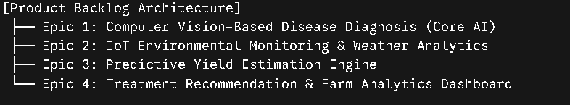
Epic 1: Computer Vision-Based Disease Diagnosis (Core AI)
User Story 1.1 (Disease Detection): As a Farmer, I want to capture and upload an image of a symptomatic plant leaf using my mobile device.
User Story 1.2 (Confidence Scoring): As an Agronomist, I want the system to attach a confidence percentage to each automated diagnosis, so that I can flag low-confidence classifications for manual expert verification.
Epic 2: IoT Environmental Monitoring & Weather Analytics
User Story 2.1 (IoT Ingestion): As a Farm Enterprise Manager, I want to connect soil moisture and temperature IoT sensors to the platform, so that I can track field environmental conditions in real time.
User Story 2.2 (Outbreak Prediction): As a Farmer, I want to receive proactive warnings when local micro-climate conditions (high humidity + specific temperature ranges) create a high risk for disease outbreaks.
Epic 3: Predictive Yield Estimation Engine
User Story 3.1 (Yield Forecasting): As a Farmer, I want to input my crop type, acreage, and historical field data into the system, so that I can receive an AI-generated crop yield forecast ahead of the harvest season.
Epic 4: Treatment Recommendation & Farm Analytics Dashboard
User Story 4.1 (Actionable Recommendations): As a Farmer, I want to receive precise, organic, or chemical treatment recommendations immediately following a positive disease diagnosis, so that I can stop the infection from spreading while minimizing unnecessary pesticide usage.
User Story 4.2 (Analytics Reporting): As a Farm Enterprise Manager, I want to generate and export monthly PDF farm analytics reports covering historical health trends

3. Define Acceptance Criteria
Disease Detection (User Story 1.1)
The system must enable farmers to capture and submit crop leaf images through the mobile application. When a tomato leaf infected with Early Blight is photographed and uploaded, the cloud-based vision inference model should process the image in under three seconds. The output must provide a clear diagnosis labeled “Early Blight” and visually highlight the infected region using a boundary box overlay. This ensures farmers receive rapid, accurate, and interpretable feedback that can be stored in their disease history log for future reference.
Outbreak Prediction (User Story 2.2)
The weather analytics worker continuously monitors environmental conditions. If humidity levels remain above 85% for 48 hours and temperatures stabilize between 20°C and 25°C, the risk analysis engine must compare these readings against historical outbreak profiles. Upon detecting a high-risk scenario for Late Blight, the system should automatically notify all registered farmers in the affected grid zone. Notifications must be delivered both via SMS and in-app alerts, with standardized wording: “High risk of Late Blight outbreak detected for potato/tomato crops in your zone. Initiate preventative measures.” These alerts must also be logged for agronomists and enterprise managers to review.
Actionable Recommendations (User Story 4.1)
Once a crop leaf image has been successfully diagnosed (e.g., powdery mildew), the application must immediately retrieve treatment protocols from the verified agronomist database. The recommendation screen should present three structured elements:
- A primary organic remedy option.
- A secondary chemical treatment option with precise dosage guidelines (e.g., “Apply 0.5% copper fungicide solution”).
- A list of safety precautions tailored to the treatment.
All recommendations must be version-controlled, timestamped, and displayed in a clear, farmer-friendly format to ensure both scientific accuracy and practical usability.

4. Prioritize the Product Backlog
The product backlog is prioritized using the MoSCoW framework combined with logical technical dependencies. Building the core image ingestion and foundational AI models must precede generating recommendations or advanced environmental correlation analytics.
Backlog ID | User Story Summary | Priority (MoSCoW) | Business Value | Dependencies
US 1.1 | Mobile image upload & instant disease detection | Must Have | Critical for initial product utility and user retention. | None
US 4.1 | Display precise treatment recommendations | Must Have | Converts raw diagnosis into actionable financial savings. | US 1.1
US 2.1 | Ingest real-time soil/temp data from IoT sensors | Should Have | Provides ground-truth data for advanced analytics. | None
US 2.2 | Send proactive micro-climate outbreak alerts | Should Have | Shifts user behavior from reactive to preventative. | US 2.1
US 3.1 | AI-generated pre-harvest crop yield forecasting | Could Have | Adds massive value for enterprise crop planning. | US 2.1
US 1.2 | Attach AI confidence metrics & tag for experts | Could Have | Drives continuous model training optimization. | US 1.1
US 4.2 | Export comprehensive monthly PDF farm analytics | Won't Have (This Sprint) | Good for business reporting but not an MVP blocker. | US 2.1, US 3.1

5. Plan the Sprint Backlog (Sprint 1)
Sprint Duration: 2 Weeks (10 working days)
The objective of Sprint 1 is to establish the minimum viable end-to-end user path: capturing a crop disease image, detecting the pathology via a cloud-based AI framework, and returning a targeted treatment protocol.
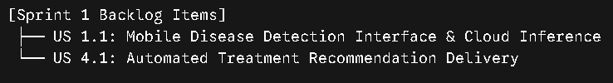
From US 1.1: Disease Detection Interface & Inference
Task 1.1.1 (Frontend – Mobile UI) Effort: ~3–4 person-days Rationale: Requires building a responsive mobile view with native camera integration, image upload canvas, and basic validation. Moderate complexity due to device compatibility and UI responsiveness.
Task 1.1.2 (Backend API – Photo Upload) Effort: ~4–5 person-days Rationale: Involves secure REST API design, handling multi-part form uploads, integration with cloud storage, and ensuring payload security. Slightly higher effort due to authentication and error handling.
Task 1.1.3 (ML Engineering – CNN Deployment) Effort: ~6–8 person-days Rationale: Requires deploying a pre-trained CNN model, setting up inference pipeline, optimizing latency (<3 seconds), and returning class probabilities. Higher effort due to ML pipeline tuning and cloud scaling.
From US 4.1: Automated Treatment System
Task 4.1.1 (Database – Treatment Mapping) Effort: ~3 person-days Rationale: Designing relational schema, seeding disease-to-treatment mappings, and ensuring agronomist validation. Relatively straightforward but requires domain consultation.
Task 4.1.2 (Integration – Treatment Retrieval) Effort: ~4–5 person-days Rationale: Writing controller logic to query treatment database, append remediation steps to API response, and ensure seamless integration with diagnosis pipeline. Moderate effort due to dependency on ML outputs.

6. Effort Estimation Using Story Points
We employ the Fibonacci sequence (1, 2, 3, 5, 8, 13) to assign story points. Estimates reflect relative complexity, technical uncertainty, and implementation effort.
User Story 1.1 – Mobile Image Upload & AI Disease Detection
Estimate: 8 Story Points
Justification: This user story embodies significant architectural and technical complexity. The mobile interface must integrate seamlessly with native hardware components, specifically the smartphone camera, to allow farmers to capture and upload crop leaf images. Beyond the frontend, the backend requires secure media streaming pipelines capable of handling multi-part image uploads, ensuring data integrity and compliance with security standards.
The most demanding aspect lies in provisioning and stabilizing the machine learning inference layer. A pre-trained convolutional neural network (CNN) must be deployed on the cloud, optimized for rapid execution, and tuned to deliver results within a strict sub-3-second round trip. Achieving this performance benchmark involves careful orchestration of cloud resources, latency reduction strategies, and robust error handling. The combination of hardware integration, secure data pipelines, and high-performance AI inference elevates this story to a high-effort item, warranting an estimate of 8 story points.
User Story 4.1 – Actionable Treatment Recommendations
Estimate: 3 Story Points
Justification: This story is comparatively straightforward, with low to moderate technical complexity. Once a disease diagnosis has been established (dependent on the successful execution of User Story 1.1), the system must query a relational database that maps disease classification codes to curated treatment protocols. The backend logic involves predictable controller patterns: retrieving the top-ranked diagnosis, performing a database lookup, and rendering text-based recommendations to the user interface.
The recommendations must include structured outputs: an organic remedy, a chemical treatment option with dosage guidelines, and safety precautions. While accuracy and domain validation are critical, the implementation relies on standard database operations and backend rendering techniques. The dependency on US 1.1 introduces sequencing considerations, but the technical workload itself is highly predictable. For this reason, the effort is estimated at 3 story points.
Summary
- US 1.1 (Disease Detection): 8 Story Points – High complexity due to hardware integration, secure pipelines, and AI inference optimization.
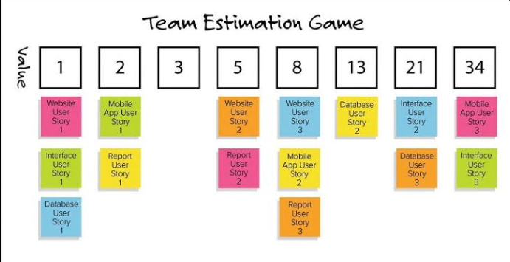
- US 4.1 (Treatment Recommendations): 3 Story Points – Low to moderate complexity, primarily database lookups and backend rendering.
Explain Relative Sizing: Clarify that story point estimation is about comparing features rather than calculating hours. The team looks at a completed task and asks, "Is this new story twice as hard, or roughly the same?"
Tie it to your project:
Point out that your User Story 4.1 (Treatment Recommendations) sits under the 3 column because it is standard data fetching and text presentation.
Your User Story 1.1 (Mobile Image Upload & AI Disease Detection) is placed further right under the 8 column because it requires complex native camera access, cloud file processing, and deep learning models.
Highlight Agile Best Practices: A board like this helps the team visually catch if too many complex stories are piling up in the higher numbers (like 13, 21, or 34), signaling that those stories need to be broken down into smaller pieces before the sprint begins.
7. Sprint Goal & Expected Deliverables
Sprint Goal
"Deliver a fully operational end-to-end core loop where a user can capture a plant leaf image on a mobile device, receive an instantaneous automated disease diagnosis, and view an actionable treatment protocol."
Native Camera Interface
A mobile application screen will be developed to provide farmers with seamless access to their device’s native camera. This interface must support both live photo capture and file selection from the local gallery. The design will emphasize responsiveness, ease of use, and compatibility across diverse smartphone models to ensure accessibility for smallholders in varying contexts.
Diagnostic Inference Engine
At the core of the system lies a cloud-deployed machine learning endpoint. This inference engine will parse incoming crop leaf images, apply trained convolutional neural network models, and identify common crop anomalies. The output must include both the disease classification and structural boundary overlays that highlight affected regions, ensuring farmers receive rapid, interpretable, and actionable insights.
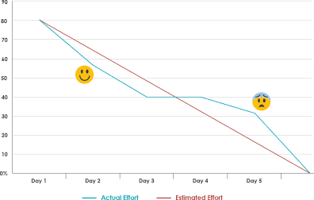

Explain the Graph Axes: The vertical axis shows the total remaining effort (measured in either story points or tasks), and the horizontal axis represents the days in the sprint cycle.
Tie it to your project:
At Day 1, the chart starts at the total scope of Sprint 1—which encompasses your core loop tasks (the native camera mobile UI, the cloud vision API setup, and the dynamic treatment card lookup table).
As the developers complete individual tasks from Section 5, the "Actual Effort" line drops downward.
Demonstrate Scrum Principles: If the actual progress stays close to or below the diagonal "Estimated Effort" line, it signals to stakeholders that the team is on track to deliver a fully functional crop disease diagnosis system by the end of the 2-week iteration.
Treatment Knowledge Library
A relational database will be seeded with curated mappings between confirmed plant diseases and verified treatment protocols. Each entry will contain both chemical and biological mitigation steps, dosage guidelines, and safety precautions validated by agronomists and plant pathologists. This library ensures that recommendations are authoritative, reproducible, and aligned with sustainable farming practices.
Integrated Response View
The mobile application will feature a unified response screen that consolidates diagnostic results with treatment guidance. Farmers will see the disease diagnosis alongside dynamic advice cards presenting organic remedies, chemical options with precise mixing criteria, and safety instructions. This integrated view transforms raw AI outputs into clear, farmer-friendly decision support, bridging technology with practical agricultural action.

